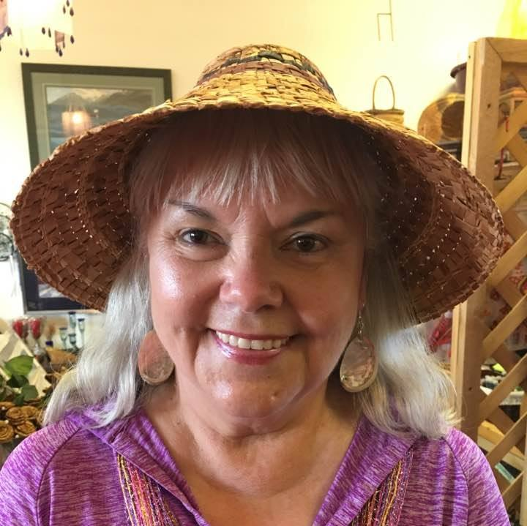

* **Can you please tell me a little about yourself? How long have you lived in Sitka? What types of things are you involved in here?**

I'm a lifelong Sitkan. I wasn't born here but came here as an infant and lived on Mt. Edgecumbe Island for 18 years and attended Sitka schools until my sophomore year when I went to Sheldon Jackson High School for my last three years of school.

Living on the island was special although I didn't realize that at the time! We caught shore boats to get to Sitka to shop, attend school, and socialize. The island was a self-contained community and provided us with everything except groceries!

I worked at ALP for 17 years and was very active in the community. I was Mrs. Claus, the Easter Bunny, the union secretary, on the hunting and fishing derby committees, was in charge of the annual picnics and belonged to the lodges. The mill was instrumental in starting the Christmas boat parade and handing out goodies to the kids after the boats tied up at Crescent Harbor. When the mill went on strike I came to work at Searhc and was there for 31 years. I was on the patient advocacy committee and we made sure that inpatients had presents if they had to be here for Christmas, that they had note paper, envelopes, stamps, and items that the hospital couldn't provide.

* **What is your biggest struggle right now?**

My biggest struggle now is coming to terms with end of life decisions. Retiring, social security, wills, power of attorneys, Medicare, it seems so final! I believe that working has kept me young and I need to be busy to keep my mind active and I also benefit from the social aspect of working.

* **Who was/is a female role model for you? Why?**

My mother was my inspiration. She and I were best friends. She was a marvel. I miss my day to day conversations with her. She was an excellent listener, she made decisions for me that I didn't necessarily agree with when I was growing up, but they were for the best (like going to high school at SJ which was both my parents’ Alma mater). She was the 1st woman in the ANB, she was the first Alaska Native woman to be superintendent of the US Park Service. She was recognized by the state and was selected to travel to foreign countries to repatriate pieces of Tlingit art. She was a powerful speaker. She was truly Andrew Hope's daughter.

* **Why do you think you were nominated to be featured on our Facebook?**

I was surprised to be nominated as a "featured everyday woman!” Perhaps due to my longevity at SAFV, which is 21 years. I came to SAFV as a client about 25 years ago when a volunteer answered a phone at their home! We've come a long way.

* **What does a normal “day in the life” look like for you?**

My normal day is still coming to work intermittently at SEARHC although we've found a possible new hire!! I'm so excited for the department and yet I'll miss them, they've been such a part of my life. I spend time with my bull dog Buster, drink my cup of coffee, read my book on Kindle, shop. I made my reservations for Celebration 2018 and need to plan some other trips now that I'll really have time!

* **Do you have something you’d like to say to other women in Sitka?**

I've been a single mom for most of my kids’ lives. It was hard to reach out to SAFV that first time. I believed what my partner told me. I thought he would find me and do the things that he told me he would do to me. I lived in a violent household for many years and will never forget what that felt like. Neither will my children. Their lives have been affected by this more than I know.

If you are experiencing physical, mental and emotional violence reach out. Don't be afraid; make that call. Even if it's just to make that first contact. If you're in a dangerous situation, we can set up a plan; if you need a shoulder, we'll be there. If you need to come in for a night, we have a place. If you need information, we have that for you. Anything we talk about will be between you and our staff. If you need some food, we can help. If you need transportation, we can send it. These services are available 24 hours a day, seven days a week.

* **What does being a strong woman mean to you?**

Being a strong woman is not easy. I've experienced loss and come through it, I've experienced tragedy and come through it. One strong woman comes to mind a remarkable southeast Alaska native leader, Ethel Lund. She was raised in Wrangell, went to nursing school in Portland, OR, worked in WA, married, moved back to Wrangell and (to cut it short) helped found SEARHC of which she was president in 1977-2000. She had insight, compassion, kindness, and her story and understanding of her people. I miss her guidance and presence. She's what strength means to me!

I've been sober 26+ years and when I quit drinking I quit smoking so that was a good thing! And another wonderful that happened to me was becoming a gramma many years ago! I appreciate the women I've met and spent time with; I wouldn't trade it for anything. Thanks for the honor! I hope to serve as long as I'm able!