**Everyday Women of Sitka: Aaní (Aanyaanáxh tláa) Perkins**

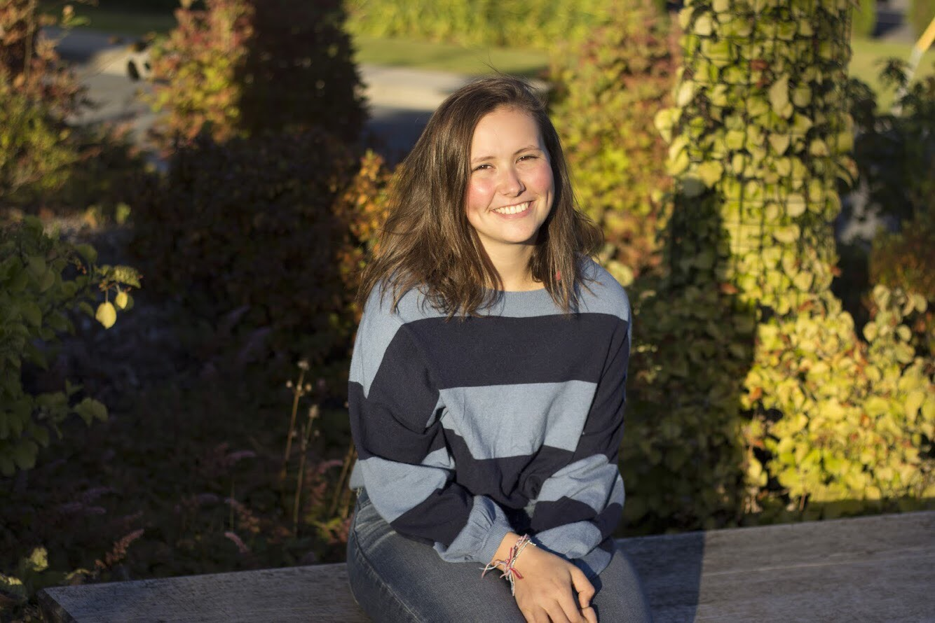

* **Can you please tell me a little about yourself? How long have you lived in Sitka? What types of things are you involved in here?**

I am in high school right now. I was born in Sitka, but I loved away for four years to Oregon for all of Middle School. I have been living in Sitka again since all of High School. In Sitka, I am involved in the Sitka Youth Leadership Committee at SAFV and am the admin intern for that. I play piano, I am on the Sitka High Mock Trial team, and on Tuesdays and Thursdays I take a distance Tlingit Language class. I used to take it locally here at UAS.

I am Tlingit myself, and that is why I am so interested in learning the language. It is really difficult. It has a whole difference word order and structure. You have to think about things really difficult when you are talking. My grandpa was actually fluent in Tlingit, but my dad never learned it. That is largely because there is this gap in time where kids were not learning the language which was a result of the boarding schools. Children would be sent to them, and they were highly discouraged to speak the language because they wanted to assimilate them. My dad is also taking classes now. We are at two different levels right now because I had to take two years off because it didn’t fit in my schedule at school.

I used to take the Tlingit classes that were offered at my school, but then they didn’t fit because they switched the period. I had to take pre-calculus instead. I am involved in student council. This week we are having a joint student council and schoolboard meeting, and each of us has certain questions or concerns we are supposed to bring up. The topic I have is culture, and I am bringing up the question of how the schoolboard can legitimize and prioritize things like Tlingit language and other culture classes. There is a certain track you are expected to go on, and Tlingit is treated like you can take it if you don’t want to take Spanish because it is easier. There is this weird school climate thing where it is not seen as legitimate. There are people like me who want to take higher classes like I was saying. I wanted to be able to take AP calculus this year, and in order to do that I had to sacrifice language and that really sucked. I don’t think it should have to be that way. You shouldn’t have to pick your culture over calculus. Schools don’t really cater to kids from different demographics. Some kids who are also native and maybe they are not excelling in school so they are not supported as much. I feel like if you are not excelling in school, you should be supported twice as much. I feel like that is a big imbalance. One way to make your education stronger and make someone excited about their learning is to actually integrate things they are interested in but that are a part of them. So if you are not being encouraged to take Tlingit or to do cultural things outside of school, it is not good. Disadvantaged people do not do things like join student council. I feel like I am very fortunate to have even felt comfortable enough to join student council my freshman year and keep going with it. The other day I was trying to think of one Native teacher at my school. Maybe I just don’t know because someone could look at me and not know right off the back or peg me as that. I don’t want to assume, but I don’t think that any teacher at my school is Native. I can think of one secretary, but not someone who is in your life on a regular basis.

* **Do you have something you’d like to say to other women in Sitka?**

I feel like that calls for an inspiring answer, and I don’t really have anything inspiring to say. I think that I would have liked to hear from other women that is ok to be proud of yourself no matter what happens or how things go. For example, it doesn’t matter if you get into the college you really want to get into or not because however much work you put into it, you should be proud of that work. You have the right to be proud of whatever you do if you are working hard for it.

* **What is your biggest struggle right now?**

I recently got accepted into my top college and that is where I am going. It doesn’t sound like a struggle, but I think lately my biggest struggle has been dealing with that. Part of me thought that if I get accepted into this school, things will be better and feel better. Part of that was true. I don’t have very high confidence levels or self-esteem, but when I got accepted into college I felt like now it was okay to feel proud of what I have done. I never felt like it was okay to feel proud of myself before. It makes sense that now I would feel validated because for a college application you put down basically everything you have done in high school, and all the stuff you have been working on for all of these years and you hope that someone will be like wow that is really cool. Aside from that, I feel that it has made me think a little more about money. College is expensive. I feel way worse than I did before in that sense. I am going to Dartmouth College. It is an Ivy League and there is a lot of elitism. I don’t think that I am elite, and I don’t think that I necessarily fit into that world exactly. That is hard, but it is also hard because a few other kids at my school got accepted into Ivys, and it is so weird to talk about money with other people that are better off than you. It is very polarizing. The other part of that is when I applied to college, I watched a lot of college application advise videos and then after that college advice videos and advice for people who are going to Ivy League schools. There is this thing called Imposter Syndrome which is comparing yourself with other people who accomplished similar things to you and feeling that you don’t deserve it. I feel like I don’t deserve it. I also feel like it is a burden to my family, and that sucks. That is really awful. That is probably like the worst feeling.

* **What does a normal “Day in the Life” look like for you?**

I track my sleep with this app, and it tells you the quality of your sleep. I start the day by snoozing this app 2 or 3 times. I do the same exact thing every morning. I make my bed and I go upstairs. I eat breakfast, I brush my teeth, I get dressed and I leave. I always listen to a podcast in the car. It is always the same podcast. Some days I go to school at 10 and some days I go at 8:30. Sometimes I have time to practice piano in the morning, and some days I just have to go to school. After school sometimes I have my internship at SAFV, sometimes I have Tlingit class, sometimes I have mock trial; it just depends.

* **What makes you proud to be a woman?**

Kind of everything. I really like the whole breaking the glass ceiling metaphor. It is terrible that is has to happen, but it is cool that men don’t get to do that. They have already been able to do everything for ever and ever. I think it is cool that women have that in common that we can see something that we have not seen another woman do before, and we can decide to do it. Or something that has never been done before. I think that girls can be really nice to each other. When I am the one being nice or the one receiving the compliment or having a nice conversation with someone. Feeling safe around each other, that makes me proud and also makes me annoyed that we have to find safe places to live. If I am walking down the street and I see a mom and her child, I automatically feel a little safer. It is nice to have that safety in somebody you don’t know.