**Everyday Women of Sitka: Sharon McIndoo**

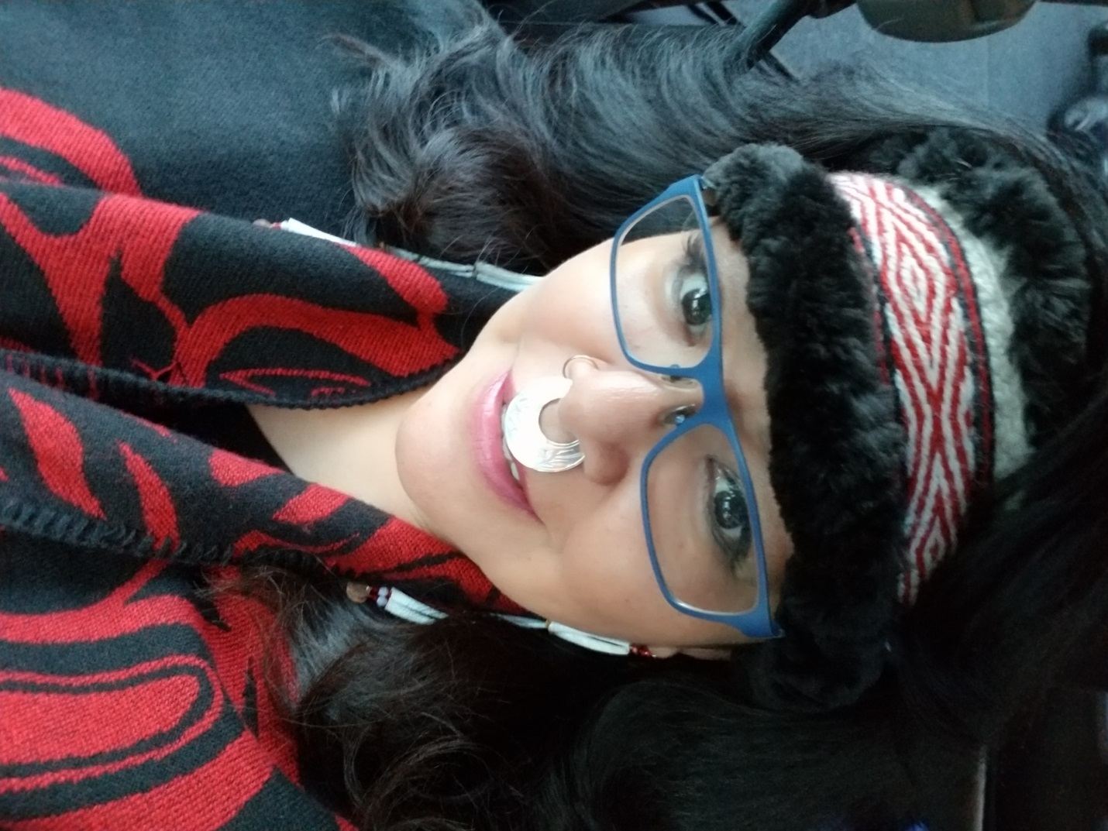

* **Can you please tell me a little about yourself? How long have you lived in Sitka? What types of things are you involved in here?**

I was born and raised in Sitka, I am Tlingit and Tsimpsean. I moved from Sitka my sophmore year in high school when my dad retired from B.I.A. on Japonski. I moved back to Sitka 10 years ago this month.

I volunteer at SAFV on Monday nights teaching a beading class from 6-8 pm. The beading is open to the public. I also work for STA, assisting with the kids in making their regalia. I have been working with CFC for the past 4 years as a Training Specialist. We take clients out for Supportive Employment, Day Hab, and Supportive living.

* **What is your biggest struggle right now?**

My biggest struggle in Sitka is a struggle most people in Sitka face, making ends meet. I work a couple jobs to pay bills. As a single person I do not have a double income coming in so I need to work a couple jobs. I am fortunate that the jobs I do have I love to do. I love working with people and there is satisfaction in seeing growth no matter how small it may be.

**What does a normal “Day in the Life” look like for you?**

A normal day? What is that? A typical Monday for me is going to work at CFC, I usually have a couple clients a day. We cover as many goals and objectives as possible in our time frame. At the end of my day at CFC I do my notes for the day, I have a short break then gather my supplies to go to the SAFV shelter for Beading Group. After group I usually call or text a friend to walk with. I get home and clean a little because getting ready for work in the morning it looks like a small tornado went through my place. I clean out my hamster, Lily's cage and then I sit down to relax.

* **What makes you proud to be a woman?**

All the roles I have had throughout my life. As we progress through life our roles change. I am the mother of 2 sons, Byron and Loren. My sons gave me eleven grandchildren, #12 is due within the next couple of weeks. My great grandson will be 3 in January.

As a Tlingit/Tsimpsean woman I feel there are certain responsibilities to being an Aunt, Grandmother etc. As an Aunt I would take my nieces and nephews for walks, pick berries or just be present in their lives. My Aunts were a big part of my childhood and life. When my first granddaughter was born I felt a physical shift in my life. My priorities changed as well as my outlook on life. I wanted to be a good role model for her and be active in her learning and her life. I wanted to be the kind of Grandma that my Grandma Daisy was to me. I was diagnosed with 2 liver diseases before my granddaughter was born so I had to make life changes. I quit smoking and drinking, I started walking, drinking more water and quit frying foods. I want to be around as long as possible and in order to do that I need to take care of myself. Beadwork was something I started doing around this time it helps me to relax and is a great way to handle stress. Self-care as a woman is so important. We sometimes carry a lot of stress, family, work and friends. I don't know about many of you but when my friends hurt I do what I can to be there for them and sometimes that is just being a good listener or support them the best I can.

I love that I can share my favorite past time with people, teaching beading or having a beading group. It helps make a natural connection when we sit around a table, we share our lives, laughter sometimes tears, hopes, dreams or prayers. We share our lives.

* **Do you have something you’d like to say to other women in Sitka?**

I would say "you are not alone", reach out for assistance, there are people who truly care and give from their heart. Being at the SAFV shelter many years ago changed my life. My advocate asked me what I what my goals were, I never thought about that before. I went college, I got really good grades. I never thought I could, I lacked self-confidence and there I was going to school and doing good. Get involved in the community, volunteers are always needed in many organizations. As a Survivor I know asking for help can be difficult. It was for me. It was something I had to learn how to do. As survivors we learn to rely on ourselves because our trust can be broken. Please know there are people always willing to assist. Sitka has a lot of wonderful caring people.

I want to thank SAFV for featuring me and giving me the opportunity to do the Monday night beading group again. Gunalcheesh Ho Ho.